Health Outcomes Among Children and Youth in Climate-Related Migration: A Scoping Review
Raghav Khanal, Sri Hari Govind, Rachael Barrett, Mahim Eaty, Oumnia Bouaddi, Hasheem Mannan*.

INTRODUCTION
In 2020, there were an estimated 281 million international migrants and 55 million internally displaced persons (IDPs) globally.¹ Migrant, refugee, and IDP populations – like any population – have an irrefutable right to health under the Universal Declaration of Human Rights. Despite this, migration status continues to be a key social determinant of health and migrant populations are made structurally and socially vulnerable to physical and mental ill health throughout the migration process due both to elevated exposure to health risks and barriers to accessing health care.² Furthermore, an increasingly stigmatising rhetoric surrounding migration in many destination countries fuels social exclusion, discrimination, and violence against migrant populations that has detrimental impacts on migrants’ physical and mental health and can directly and indirectly prevent access to healthcare. Particular migrant populations such as refugees, IDPs (who remain within their state of origin), and irregular migrants also face additional and unique barriers to health.² Migrant populations are anticipated to grow as the impacts of climate change forces people to leave their homes due to loss of habitable land and livelihoods as well as acute health risks.³ In 2021, the World Bank projected that without climate action 216 million people could be forced to relocate within states by 2050.⁴ Such climate change migration is already documented in many global regions and the nexus of climate change, migration and health is increasingly explored in peer-reviewed literature.^{5–9}
However, migrant populations are not homogenous- with considerable diversity in terms of gender, age, sexuality, ethnicity, race, country of origin, and length of stay that can also impact individual health. Children, adolescents and youth make up a considerable proportion of migrant populations globally, with an estimated 36 million migrants being under the age of 18 in 2020.¹⁰ Young migrants – especially when unaccompanied- can face increased health risks, including under-nutrition, emotional distress and trauma, and exposure to unsafe substances, sexual behaviours, and employment practices that result in acute and long-term health problems.² Yet, child, adolescent and youth migrants are largely underrepresented in global migration discourse which culminates in a lack of evidence in these vulnerable populations, particularly adolescents and youth.^{2,11} To address this research gap, we seek to assess the health impact and challenges faced as a result of climate change migration on this under-studied population. Previous systematic and scoping reviews have noted the adverse health consequences arising from climate change associated displacement, but failed to focus on this vulnerable population.^{12,13} To fill this gap, with the intention of spurring research and policy adapted to the needs of this young population, we ask:
- According to existing literature, what are the health outcomes of climate change migration on children and youth?
- Where is further research needed to inform meaningful policy to protect the health of young climate migrants?

METHOD
To answer these questions, we will perform a scoping review of peer-reviewed literature based on the framework of Arksey and O’Malley and in alignment with the PRISMA-ScR guidelines.^{14,15}
Definitions
In this work we will utilize the definition of climate change migration submitted by the International Organization for Migration to the Warsaw International Mechanism Executive Committee under the UNFCCC. Specifically, climate change migration is defined as ‘the movement, within a state or across an international border, of a person or a groups of persons, who are obliged or choose to leave their habitual place of residence either temporarily or permanently predominantly for the reasons of sudden or progressive change in the environment due to climate change.’¹⁶ To operationalise this in our method a population will be considered climate change migrants only if their movement is linked to environmental changes associated with or sensitive to climate change.
Similarly, our focus on children, adolescents, and youth refers exclusively to individuals between the ages of 5 to 24 to align with the United Nations’ definition.¹⁷ The decision was taken to exclude children under five, infants and newborns from the purview of this scoping review due to the separate and unique health challenges faced in these early years.
Search strategy and reference selection
We will search in 4 major biomedical databases including Medline, Embase and Psycinfo via OVID platform and CINAHL to identify peer-reviewed primary studies documenting the health outcomes or challenges of children, adolescents, and youth on the move because of climate change. These databases will be searched by using a search strategy that was iteratively refined in accordance with the research objectives, capacity of the research team, with the assistance of a librarian, and by testing using key references. The search will include articles published in any language translation software will be used for articles published in languages other than English. Annex 2 provides an example search. All identified search results from the three databases will be uploaded to Rayyan.ai review management software and de-duplicated. In addition to database searches, we will also conduct manual searches, including screening the reference lists of relevant scoping and systematic reviews to identify additional eligible study.
Articles will be initially screened by title and abstract by four members of the research team according to the inclusion and exclusion criteria (Table 1). Those thought relevant at the title and abstract stage will then undergo a full text screen according to the same criteria. Uncertainties regarding reference relevance at either stage will be resolved through discussion on a case-by-case basis by the research team. Relevant secondary studies will be included in the first stage of screening to allow for reference lists to be searched, but only primary studies will be ultimately eligible for inclusion.

Table 1. Inclusion and exclusion criteria
Inclusion
- Focus on children, adolescents, or youth aged 5–24 years, in alignment with the United Nations definition¹⁷. Studies including broader age ranges will be eligible if results are disaggregated for this age group, if the mean or median age falls within 5–24 years, or if at least 50% of participants are aged 5–24 years.
- Include migrants, refugees, asylum seekers, or internally displaced persons whose movement is explicitly attributed to climate change or climate-related environmental change (e.g., drought, flooding, sea-level rise, heatwaves, desertification, storms), including both long term and short term displacement.
- Any type of health outcomes or challenges reported.
- Peer-reviewed primary research studies with any design (quantitative, qualitative, mixed methods, observational, or interventional, including randomised controlled trials).
- Conducted in any country and at any stage of migration
Exclusion
- Focus exclusively on populations outside the 5–24 age range (e.g., under 5 years or over 24 years) without extractable data for the target group.
- Examine migration not explicitly linked to climate and events classified as geophysical (e.g., earthquakes, tsunami, volcanic eruptions,etc) will be excluded as non-climate-related hazards.
- Studies with multiple cause of displacement will also be excluded.
- Are review articles, commentaries, editorials, opinion pieces, conference abstracts, or other non-primary or non–peer-reviewed studies.

Data extraction
Data will be extracted from all articles included after the final screening stage using an extraction template designed in Excel to capture relevant information. Provisional topics of data extraction include:
- Reference details (Authors, title, year of publication, journal)
- Population (Country and location, type of migrant population, point in migration, age range, length of residence)
- Role of climate change (Driver of migration, details)
- Health outcome (Type of health issue discussed, specific health outcome(s) measured, how were health outcomes measured)
- Study design (Method, control population if any)
- Key findings and conclusions
Extracted information will inform the development of summary tables and the subsequent analysis and conclusions. No quality assessment of included articles will be conducted as is standard for scoping reviews.¹⁴

Methodology
Guiding frameworks of this scoping review will be:
- Arksey and O’Malley framework
- PRISMA-ScR guidelines

1. Definitions

Climate migration: The movement, within a State or across an international border, of a person or groups of persons, who are obliged to leave their habitual place of residence, or choose to do so, either temporarily or permanently, predominantly for reasons of sudden or progressive change in their environment due to climate change¹⁸.
Children: The convention on the Rights of the child defines child as every human being below the age of eighteen years unless under the law applicable to the child, majority is attained earlier¹⁹.
Youth Definition: No children under 5, According to the UN Secretariat, it uses the terms youth and young people interchangeable to mean age 15-24 with the understanding that member states and other entities use different definitions²⁰.
Migrant: A migrant is a person who moves away from their usual residence within a country or across international borders, regardless of legal status, reason for movement, or duration of stay ²¹.
IDP: "Persons or groups of persons who have been forced or obliged to flee or to leave their homes or places of habitual residence, in particular as a result of or in order to avoid the effects of armed conflict, situations of generalized violence, violations of human rights or natural or human-made disasters, and who have not crossed an internationally recognized State border”. (Guiding Principles on Internal Displacement, 1998)²².

2. PCC Framework, General list of terms

Population (two subsets) | ((child* or adolescen* or teen* or youth* or young or minor* or juvenil* or paediatric* or pediatric* or puber* or pre-pubescent or jeune* or *mineur* or “jeune adulte” or pubescen* or “school age*” OR adolescent/ or young adult/ or child/) AND (migr* or immigr* or emigr* or outmigrat* or refugee* or asylum* or undocument* or non-citizen or citizenship* or transient* or displac* or expat* or nationalit* or non-resident* or newly-arrived or newcomer* or new-comer* or foreign-born or country ajd3 origin* or diaspora* or “population movement*” or “border crossing*” or “unaccompanied minor*”or refugi* or asile or etrang* or sans-papiers or transitoire* or citoyen*).ti,ab  or exp human migration/ or exp “transients and migrants”/ or exp refugees/ or exp emigrants and immigrants/ ))
Climate change (context) | exp climate change/ or exp greenhouse effect/ or exp extreme weather/ or exp environmental change/ or exp natural disasters/  or “climate change*” or “global warming” or “climate variability” or “climatic variability” or “sea level*” or “greenhouse effect*” or “extreme weather” or “environmental change*” or “climate disaster*” or “natural disaster*” or “natural hazard*” or drought* or famine* or flood* or heat* or wildfire* or desertification or “ocean acidification” or pollut* or “air quality” or “water scarcity” or “water stress*” or storm* or climat* or environment* or desertif* or “changement climatique” or “réchauffement” or “food production” or “sea level” or “extreme weather events” or “air pollution” or Climate OR Heat waves OR Meteorological factors OR Snow OR Heavy rain OR Flooding OR Extreme weather events OR Weather OR Warming OR Climate change intervention OR Climate change adaptation OR Atmosphere OR Greenhouse effect OR allergens OR Ozone OR Suspended Particulate Matter OR Aeroallergens OR Arid OR Rain OR Climatic factors Or Relative humidity OR Precipitation OR Temperature OR Seasonality
Health outcomes (optional, try with and w/o) (concept) | Morbidity OR Mortality OR Health OR Disease OR Injury OR Death OR Non-communicable diseases OR Cancer OR Cardiovascular disease OR Diabetes OR Hypertension OR Myocardial infarction OR Cerebrovascular disease OR Stroke OR Respiratory OR Mental health OR Depression OR Schizophrenia OR Neurological OR Stress-Related disorders OR Health care OR Health services OR Asthma OR Allergies OR Airway OR Food insecurity OR Food security OR Hunger OR Malnutrition OR Health center OR Hospital OR Infection OR Diarrhea OR Waterborne OR Vector OR Trachoma OR Nutrition OR Cyanide OR Malaria OR Schistosomiasis OR Typhoid fever OR Amoebiasis OR Cholera OR Hepatitis A OR Salmonellosis OR Shigellosis OR Dengue OR Onchocerciasis OR Japanese encephalitis OR Scabies OR Impetigo OR Respiratory OR malnutrition OR Trauma

5. Analysis
Based on extracted data from the included articles we will synthesis the outcomes alligned to the overview of climate-sensitive health risks pathway.
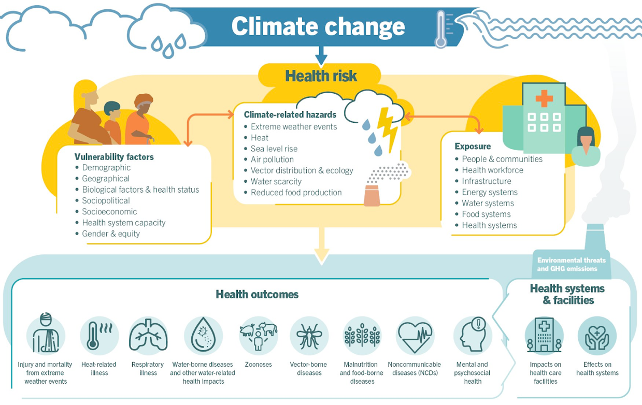
Source: WHO ²³.

Health outcomes may be classified as:
- heat-related illness
- respiratory illness
- water-born diseases
- vector born diseases
- malnutrition and food borne diseases
- non-communicable diseases
- mental health.

REFERENCES
- International Organization for Migration. World Migration Report 2022 [Internet]. Geneva: IOM; 2020 [cited 2023 Nov 10]. Available from: https://publications.iom.int/books/world-migration-report-2022

- Abubakar I, Aldridge RW, Devakumar D, Orcutt M, Burns R, Barreto ML, et al. The UCL–Lancet Commission on Migration and Health: the health of a world on the move. Lancet. 2018;392(10164):2606–54. doi:10.1016/S0140-6736(18)32114-7

- McMichael C, Barnett J, McMichael AJ. An ill wind? Climate change, migration, and health. Environ Health Perspect. 2012;120(5):646–54. doi:10.1289/ehp.1104375

- Clement V, Rigaud KK, de Sherbinin A, Jones B, Adamo S, Schewe J, et al. Groundswell Part 2: Acting on Internal Climate Migration [Internet]. Washington, DC: World Bank; 2021 [cited 2023 Nov 10]. Available from: http://hdl.handle.net/10986/36248

- Ahsan R. Climate induced migration: lessons from Bangladesh. Int J Climate Change: Impacts Responses. 2014;5(1):1–12.

- World Bank. Climate Change and Migration: Evidence from the Middle East and North Africa. Washington, DC: World Bank; 2014.

- Nawrotzki RJ, Hunter LM, Runfola DM, Riosmena F. Climate change as a migration driver from rural and urban Mexico. Environ Res Lett. 2015;10(11):114023. doi:10.1088/1748-9326/10/11/114023

- Baez J, Caruso G, Mueller V, Niu C. Droughts augment youth migration in Northern Latin America and the Caribbean. Clim Change. 2017;140(3):423–35. doi:10.1007/s10584-016-1863-2

- Schütte S, Gemenne F, Zaman M, Flahault A, Depoux A. Connecting planetary health, climate change, and migration. Lancet Planet Health. 2018;2(2):e58–9. doi:10.1016/S2542-5196(18)30004-4

- UNICEF. Child migration [Internet]. UNICEF DATA; [cited 2023 Nov 10]. Available from: https://data.unicef.org/topic/child-migration-and-displacement/migration/

- Sidney BT, Chandras S, Campbell SM, Salma J, Yamamoto SS. Health-related impacts of climate change and air pollution on older adult, child, and adolescent immigrants and refugees globally: a scoping review. J Public Health (Berl) [Internet]. 2023 Oct 14 [cited 2023 Nov 10]. doi:10.1007/s10389-023-02103-z

- Mazhin SA, Khankeh H, Farrokhi M, Aminizadeh M, Poursadeqiyan M. Migration health crisis associated with climate change: a systematic review. J Educ Health Promot. 2020;9:97. doi:10.4103/jehp.jehp_4_20

- van Daalen KR, Dada S, Issa R, Chen H, de Albuquerque R, Abayomi O, et al. A scoping review to assess sexual and reproductive health outcomes, challenges and recommendations in the context of climate migration. Front Glob Womens Health [Internet]. 2021 [cited 2023 Nov 2];2:757153. Available from: https://www.frontiersin.org/articles/10.3389/fgwh.2021.757153

- Arksey H, O’Malley L. Scoping studies: towards a methodological framework. Int J Soc Res Methodol. 2005;8(1):19–32. [cited 2023 Nov 10]. Available from: https://www.tandfonline.com/doi/abs/10.1080/1364557032000119616

- Tricco AC, Lillie E, Zarin W, O’Brien KK, Colquhoun H, Levac D, et al. PRISMA extension for scoping reviews (PRISMA-ScR): checklist and explanation. Ann Intern Med. 2018;169(7):467–73. [cited 2023 Nov 10]. Available from: https://www.acpjournals.org/doi/full/10.7326/M18-0850

- International Organization for Migration. Submission to the Executive Committee of the Warsaw International Mechanism for Loss and Damage: migration, displacement and human mobility and climate change [Internet]. Geneva: IOM; 2016 [cited 2026 Mar 15]. Available from: https://unfccc.int/files/adaptation/groups_committees/loss_and_damage_executive_committee/application/pdf/excom_wim_aa6_iom_submission_submitted_16_may_2016_1.pdf

- United Nations. Youth [Internet]. United Nations; [cited 2023 Nov 10]. Available from: https://www.un.org/en/global-issues/youth

- United Nations Human Rights Office of the High Commissioner. Convention on the Rights of the Child [Internet]. OHCHR; [cited 2026 Mar 15]. Available from: https://www.ohchr.org/en/instruments-mechanisms/instruments/convention-rights-child

- United Nations. Youth definition [Internet]. New York: United Nations; [cited 2026 Mar 15]. Available from: https://www.un.org/esa/socdev/documents/youth/fact-sheets/youth-definition.pdf

- United Nations. Migrants [Internet]. United Nations; [cited 2026 Mar 15]. Available from: https://www.un.org/en/fight-racism/vulnerable-groups/migrants

- UNHCR. Guiding Principles on Internal Displacement [Internet]. Geneva: UNHCR; [cited 2026 Mar 15]. Available from: https://www.unhcr.org/media/guiding-principles-internal-displacement

- Scoping Review. excom_wim_aa6_iom_submission_submitted_16_may_2016_1.pdf [Internet]. UNFCCC; [cited 2023 Nov 10]. Available from: https://unfccc.int/files/adaptation/groups_committees/loss_and_damage_executive_committee/application/pdf/excom_wim_aa6_iom_submission_submitted_16_may_2016_1.pdf

- World Health Organization. Climate change and health [Internet]. WHO; 2023 Oct 12 [cited 2026 Mar 15]. Available from: https://www.who.int/news-room/fact-sheets/detail/climate-change-and-health

